**Student Activity Guide: Encoding a B&W image** Name: ____________

Unit 1 Lesson 11

**Scenario**

In your new role as a computer scientist at NASA, you have joined the team responsible for encoding images that will be sent into space, in the hopes that someday an intelligent life form might capture the stream of bits, be able to reconstruct the images, and learn about life on earth during the 21st Century. Think of it as a “message in a bottle” tossed into space. You have been assigned to develop and test an encoding scheme for the team.

**Directions**

1. Use a grid such as graphing paper to sketching a simple B&W image.
2. Access [Pixelation tool v.2 *(http://bit.ly/pixeltoolv2*](http://bit.ly/pixeltoolv2)*)*
3. Use the Pixelation tool to create and encode the image.
4. Use the following screen capture image as a guide.

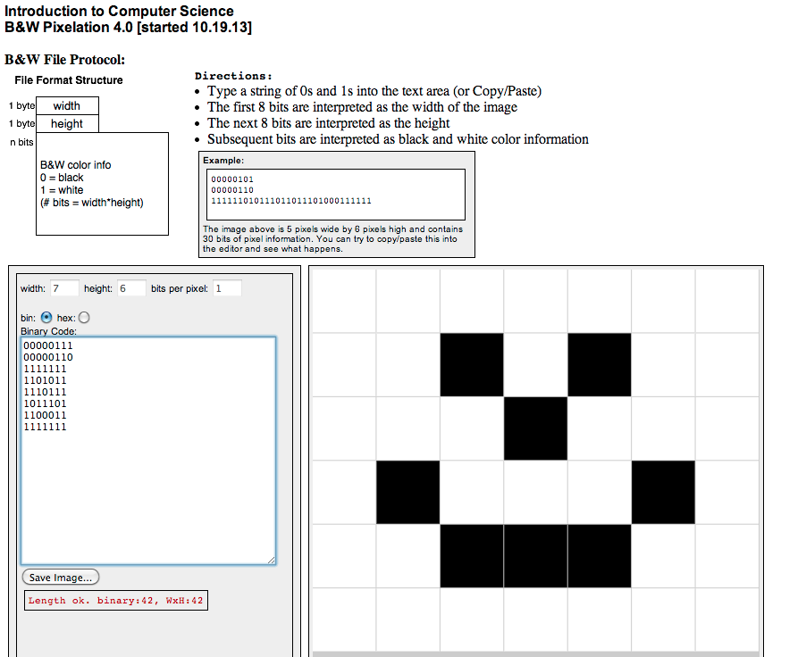

1. Test your work by decoding (reversing the process) the stream of bits using the Pixelation tool v.2.
2. Submit your work by sending the stream of bits to your teacher.
3. Share bit streams with other students. Decode the streams to discover their images.

Did You Know? *This is similar to the task space scientists performed to encode an image to be sent into space with the Voyager satellite.*